

**RAJALAKSHMI ENGINEERING COLLEGE**

**DEPARTMENT OF MECHATRONICS ENGINEERING**

**ANNA UNIVERSITY, CHENNAI**

# APRIL 2023

IOT BASED VEHICLE EMISSION MONITORING SYSTEM

**PROJECT REPORT**

***Submitted by***

# ABISHEK S - 2116201201001

# AVANEESH SRIRAM - 2116201201007

# KAUSHIK S - 2116201201020

***in partial fulfillment for the award of the degree of***

**BACHELOR OF ENGINEERING IN**

**MECHATRONICS ENGINEERING**

**MAY 2023**

RAJALAKSHMI ENGINEERING COLLEGE

**(An Autonomous Institution, Affiliated to Anna University, Chennai)**

# BONAFIDE CERTIFICATE

Certified that this Report titled “**IOT BASED VEHICLE EMISSION MONITORING SYSTEM**” is the bonafide work of **ABISHEK S (2116201201001), AVANEESH SRIRAM (2116201201007), KAUSHIK S (2116201201020)** who carried out the work under my supervision. Certified further that to the best of my knowledge the work reported herein does not form part of any other thesis or dissertation on the basis of which a degree or award was conferred on an earlier occasion on this or any other candidate.

Dr SANTHANAM.V,

Professor and Head,

Department of Mechatronics Engineering, Rajalakshmi Engineering College, Chennai - 602 105.

Dr. BALAKARTHIKEYAN M

Associate Professor,

Department of Mechatronics Engineering, Rajalakshmi Engineering College, Chennai - 602 105.

This project is submitted for VIVA-VOICE Examination held on at

Rajalakshmi Engineering College, Chennai.

INTERNAL EXAMINER

# ABSTRACT

Vehicle emissions refer to the gases and particles that are released into the air as a result of the combustion of fuel in a vehicle's engine. These emissions include pollutants such as carbon monoxide, nitrogen oxides, chlorofluorocarbon and particulate matter which can contribute to air pollution and have negative impacts on human health and the environment.

As a result, there is a pressing need to reduce emissions through various measures, such as transitioning to cleaner energy sources, improving energy efficiency, and adopting sustainable practices in college campuses. Additionally, policies and regulations aimed at reducing emissions have been implemented globally.

The urgency to reduce emissions is driven by the need to mitigate the impacts of climate change and protect human health and the environment. Continued efforts are necessary to address this critical issue and achieve a more sustainable future.

The IoT-enabled sensor-based emissions monitoring system proposed in this project is designed to promote environmental sustainability on college campuses. The system is made up of strategically deployed sensors that are able to detect emissions from vehicles, and measure various environmental parameters. These sensors are connected to a centralized data processing and visualization platform that provides real-time data analysis and display.

The system is able to provide early detection of potential emission sources, identify emission hotspots, and track emissions trends over time. This information can be used to develop proactive measures for emission reduction and energy optimization, which ultimately promote sustainable practices on college campuses.

To ensure that the system is effective, additional automated systems will be developed to work alongside the emissions monitoring system. These automated systems will help to reduce emissions even further, by optimizing energy usage and minimizing waste. By doing so, the system will not only help to reduce emissions on college campuses but will also contribute to a more sustainable future.

**ACKNOWLEDGEMENT**

Initially we thank the almighty for being with us through every walk life. It is our privilege to express our sincerest thanks to our respected Chairman **Mr. S. Meganathan, B.E., F.I.E** and beloved Chairperson **Dr. Mrs. Thangam Meganathan, M.A., M.Phil., Ph.D**. and beloved Vice-chairman, **Mr. M. Abhay Shankar Meganathan, B.E., M.S** for providing us with the requisite infrastructure and extending support in all endeavors.

Our heartfelt thanks to **Dr. S. N. Murugesan, M.E., Ph.D**., our Principal for deeply express our sincere thanks to **Dr. V. Santhanam, M.E., Ph.D.,** Head of the Department, Department of Mechatronics Engineering for his encouragement and continues support to complete the project in time.

We gratefully acknowledge and thank **DR. S. P. Srinivasan, Ph.D.,** Department Mechanical Sciences for giving us an opportunity to do project work. We are glad to express our sincere thanks and regards to our supervisor D**r. M. Balakarthikeyan, M.E, Ph.D.,**. Associate Professor, Department of Mechatronics Engineering and our coordinator, **Mr.V. Kanagaraj, M.E, Ph.D.,**.Asistant Professor, Department of Mechatronics Engineering for their guidance and suggestion throughout the course of the project.

# ABISHEK S

# AVANEESH SRIRAM

# KAUSHIK S

**TABLE OF CONTENTS**

|  |  |  |  |  |
| --- | --- | --- | --- | --- |
| **S.NO** |  |  | **TITLE** | **PG. NO** |
|  |  |  | **ABSTRACT** | i |
|  |  |  | **ACKNOWLEDGEMENT** | iii |
|  |  |  | **LIST OF FIGURES** | vi |
| **1** |  |  | **INTRODUCTION** | 1 |
|  | 1.1 |  | OVERVIEW FOR THE INTRODUCTION | 1 |
|  | 1.2 |  | MOTIVATION | 2 |
|  | 1.3 |  | PROBLEM STATEMENT | 2 |
|  | 1.4 |  | COMPONENTS DESCRIPTION | 3 |
|  |  | 1.4.1 | ARDUINO UNO | 3 |
|  |  | 1.4.2 | ESP8266 Wi-Fi MODULE | 4 |
|  |  | 14.3 | PM10 SENSOR | 5 |
|  |  | 1.4.4 | TGS3830 SENSOR | 6 |
|  |  | 1.4.5 | MQ7 SENSOR | 7 |
|  |  | 1.4.6 | ELECTROCHEMICALOXYGEN SENSOR | 8 |
|  |  | 1.4.7 | MG811 SENSOR | 9 |
|  |  | 1.4.8 | LCD DISPLAY | 10 |
|  | 1.5  1.6 |  | RANGE OF THE SENSORS  SOFTWARE USED | 11  11 |
|  |  | 1.6.1 | ARDUINO IDE | 11 |
|  |  | 1.6.2 | PROTEUS | 12 |
| **2** |  |  | **LITERATURE REVIEW** | 14 |
|  | 2.1 |  | REVIEW OF LITERATURE | 14 |
|  |  | 2.1.1 | EFFECTS OF THE VECHICULAR EMISSION ON THE URBAN ENVIRONMENT | 14 |
|  |  | 2.1.2 | A REVIEW OF MAJOR CHOLOROFLUROCARBONS | 15 |
|  |  | 2.1.3 | TROPOSPHERIC EMISSION (TEMPO) | 16 |
|  |  | 2.1.4 | REVIEW ON VEHICLE EXHAUST EMISSION MONITROING SYSTEM | 17 |
|  |  | 2.1.5 | IOT BASED VEHICLE EMISSION MONITORING SYSTEM | 18 |
| **3** |  |  | **METHODOLOGY** | 20 |
|  | 3.1 |  | PROPOSED MODEL | 20 |
|  | 3.2 |  | FLOWCHART OF THE PROPOSED MODEL | 21 |
|  |  | 3.2.1 | EXPLANATION OF THE FLOWCHART | 21 |
|  | 3.3 |  | DATAFLOW OF THE PROPOSED SOLUTION | 22 |
|  | 3.4 |  | BLOCK DIAGRAM OF THE PROPOSED SOLUTON | 23 |
|  |  | 3.4.1 | WORKING OF THE BLOCK DIAGRAM | 23 |
| **4** |  |  | **RESULT AND DISCUSSION** | 26 |
|  | 4.1 |  | RESULT | 26 |
| **5** |  |  | **CONCLUSION** | 27 |
|  | 5.1 |  | CONCLUSION | 27 |
|  | 5.2 |  | FUTURE WORK | 28 |
| **6** |  |  | **REFERENCES** | 29 |
|  |  |  | **APPENDIX** | 31 |

**LIST OF FIGURES**

|  |  |  |
| --- | --- | --- |
| **S.NO** | **FIGURE NAME** | **PG.NO** |
| 1.1 | Arduino UNO | 4 |
| 1.2 | ESP8266 Wi-Fi Module | 5 |
| 1.3 | PM10 Sensor | 6 |
| 1.4 | TGS3830 Sensor | 7 |
| 1.5 | MQ7 Sensor | 8 |
| 1.6 | Electrochemical Oxygen Sensor | 9 |
| 1.7 | MG811 Sensor | 10 |
| 1.8 | LCD Display | 10 |
| 3.1 | Flowchart of the proposed solution | 21 |
| 3.2 | Data flow of the proposed solution | 22 |
| 3.3 | Block diagram of the proposed solution | 23 |
| 3.4 | Front view of the proposed solution | 24 |
| 3.5 | Isometric view of the proposed solution | 25 |
| 4.1 | Circuit diagram of the proposed solution | 26 |

**CHAPTER 1**

**INTRODUCTION**

* 1. **OVERVIEW FOR THE INTRODUCTION**

Vehicle emission monitoring systems are an essential part of efforts to reduce air pollution and improve air quality. These systems are designed to measure the amount of pollutants that are released by vehicles, and to ensure that they comply with local and national regulations.

The primary goal of emission monitoring systems is to reduce the harmful impact of vehicle emissions on human health and the environment. These emissions can cause a variety of health problems, including respiratory issues, heart disease, and cancer. In addition, they can contribute to climate change and other environmental issues.

Emission monitoring systems use various sensors and technologies to measure the levels of pollutants that are released by vehicles. These systems can detect a variety of pollutants, including carbon monoxide, nitrogen oxides, particulate matter, and volatile organic compounds. By measuring these pollutants, emission monitoring systems can provide valuable data that can be used to identify sources of pollution and to develop strategies for reducing emissions.

Overall, vehicle emission monitoring systems play a crucial role in promoting cleaner, healthier air. As technology continues to advance, these systems are likely to become even more effective at reducing the impact of vehicle emissions on the environment and public health.

Our project will be placed within the campus to monitor the emissions from vehicles which changes the oxygen levels drastically. This can be used to determine the percentage of different pollutants emitted, further giving us the advantage to control the emission in order to maintain the oxygen level.

**1.2 MOTIVATION**

Vehicle monitoring systems are designed to address several key motivations, including environmental protection, public health, energy efficiency, and corporate responsibility. By reducing harmful pollutants released into the atmosphere, vehicle monitoring systems help protect the environment and promote public health. With the help of required sensors, Arduino uno and a Wi-fi module (ESP8266), a system can be designed which can help monitor and maintain the pollutants present in the environment.

**1.3 PROBLEM STATEMENT**

Emissions from industrial processes can have severe consequences on the environment and public health. The current methods of monitoring and controlling these emissions often rely on manual data collection and analysis, which can be time-consuming, inaccurate, and prone to errors.

Additionally, traditional monitoring systems can be expensive and require significant resources for maintenance and operation. To address these challenges, a modern, efficient, and cost-effective emission monitoring system is needed. This system will utilize IoT technology and sensors integrated on a microcontroller to collect real-time data on emissions from industrial sources. The data will then be transmitted wirelessly to a cloud-based platform for analysis and visualization.

The proposed system will provide stakeholders, including regulatory agencies, industries, and the public, with accurate and timely data for informed decision-making and effective emissions management. By leveraging the power of IoT technology, the system will improve the accuracy and efficiency of emissions monitoring, reduce the negative impact of emissions on the environment and public health, and help industries meet their regulatory compliance requirements.

Ultimately, the project aims to create a more sustainable future by reducing the environmental impact of industrial emissions and improving public health. The use of sensors integrated on a microcontroller and IoT technology will revolutionize the way emissions are monitored, providing stakeholders with real-time data that is reliable, cost-effective, and easy to use.

**1.4 COMPONENTS DESCRIPTION**

The vehicle emission monitoring system requires few sensors, a controller and a wi-fi module for its efficient functioning. Usage of IOT enables continuous monitoring to provide information regarding the emissions from the vehicles. A display unit is also required in order to give information to the users regarding the levels of emission from the vehicles.

**1.4.1 ARDUINO UNO**

Arduino Uno is an ideal platform for prototyping electronic projects. With its open-source software and hardware, it is a versatile and cost-effective solution that allows users to design, program, and test their ideas quickly and easily. The board is compatible with a range of programming languages, including C and C++, making it accessible to developers of all levels of expertise. Additionally, it has a large and supportive community of users who share their knowledge and experience, making it easy to find resources and solutions to common problems.

One of the key features of the Arduino Uno board is its compatibility with a range of shields. These shields are add-on boards that can be used to expand the capabilities of the board, allowing it to interface with other devices and sensors. For example, a Wi-Fi shield can be used to add internet connectivity to the board, while a motor shield can be used to control the speed and direction of a motor. This makes it easy to add additional functionality to your projects without the need for additional hardware or programming expertise.

Another advantage of the Arduino Uno board is its simplicity. The board is designed to be easy to use, with a straightforward and intuitive interface that allows users to quickly get started with their projects. Additionally, the board is equipped with a range of built-in features, including a USB port for programming and a power regulator, making it easy to power and program the projects.

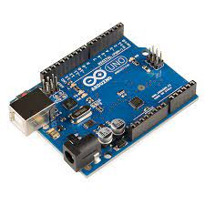

***Fig 1.1: Arduino Uno***

**1.4.2 Wi-Fi MODULE ESP8266**

The Wi-Fi module ESP8266 is a low-cost and highly integrated wireless platform that has become popular for IoT applications. It is designed to provide Wi-Fi connectivity to microcontrollers such as the Arduino Uno, allowing them to connect to the internet and communicate with other devices. The module features a built-in TCP/IP protocol stack, making it easy to connect to the internet and send and receive data. It also has a range of GPIO pins that can be used to interface with sensors and other devices.

One of the key advantages of the ESP8266 is its low cost. It is available for a fraction of the cost of other Wi-Fi modules, making it an affordable option for IoT projects. Additionally, it is highly versatile and can be used in a range of applications, from home automation to industrial control systems. With the right programming, it can be used to control lights, monitor temperature and humidity, and even control motors and other mechanical devices.

In summary, the ESP8266 Wi-Fi module is a powerful and cost-effective tool for connecting microcontrollers to the internet. Its low cost, versatility, and ease of use make it a popular choice for IoT projects of all types, from hobbyist projects to industrial applications. Whether you are looking to control your home's lights and appliances, monitor environmental conditions, or create a robot that can connect to the internet, the ESP8266 is an excellent choice.

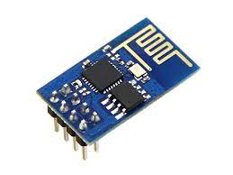

***Fig 1.2: ESP8266 Wi-Fi Module***

**1.4.3 PM10 SENSOR**

The PM10 sensor is a type of particulate matter sensor that measures the concentration of particles in the air that are 10 microns or smaller in diameter. These particles can be harmful to human health, particularly when they are inhaled, as they can penetrate deep into the lungs and cause respiratory problems. The PM10 sensor works by using a laser to detect the concentration of particles in the air, and then converting this measurement into a numerical value that can be used to monitor air quality.

PM10 sensors are becoming increasingly important in cities and other areas with high levels of air pollution. They are used by environmental monitoring agencies to measure air quality and provide warnings when levels of pollution reach dangerous levels. Additionally, they can be used by individuals to monitor the air quality in their homes or workplaces and take steps to reduce exposure to harmful particles. PM10 sensors are often used in conjunction with other types of air quality sensors, such as those that measure levels of carbon dioxide or nitrogen oxides, to provide a comprehensive picture of air quality.

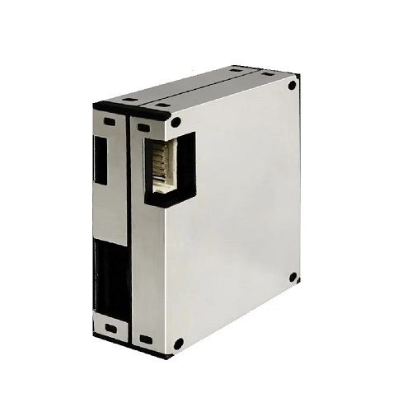

***Fig 1.3: PM10 Sensor***

**1.4.4 TGS3830 SENSOR**

The TGS3830 sensor is a type of gas sensor that is used to detect the presence of harmful gases in the air, such as carbon monoxide and nitrogen dioxide. It works by using a semiconductor material that changes its electrical resistance when it comes into contact with the gas being detected. This change in resistance is then converted into a numerical value that can be used to monitor gas levels. The TGS3830 sensor is known for its high sensitivity and accuracy, making it a popular choice for industrial and environmental monitoring applications.

One of the key advantages of the TGS3830 sensor is its versatility. It can be used to detect a wide range of gases, making it suitable for a variety of applications. Additionally, it is small and compact, making it easy to integrate into existing systems. This makes it a popular choice for applications such as air quality monitoring in homes and workplaces, industrial safety monitoring, and automotive emissions testing. With the ability to detect harmful gases quickly and accurately, the TGS3830 sensor plays an important role in keeping people and the environment safe.

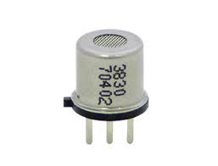

***Fig 1.4: TGS3830-CFC Sensor***

**1.4.5. MQ-7 SENSOR**

The MQ-7 is a type of gas sensor that is commonly used to detect the presence of carbon monoxide (CO) gas in the air. It is a small, low-cost sensor that operates on the principle of chemoreceptive detection, where the resistance of the sensing element changes in the presence of a target gas.

The MQ-7 sensor consists of a sensing element made of tin dioxide (SnO2), which is sensitive to carbon monoxide gas. The sensing element is heated to a high temperature, typically around 400-500 degrees Celsius, to increase its sensitivity to CO gas.

When CO gas is present in the air, it reacts with the sensing element and causes a change in its electrical resistance. This change in resistance is proportional to the concentration of CO gas in the air and can be measured and used to determine the level of CO gas present.

The MQ-7 sensor is commonly used in applications such as carbon monoxide detectors, gas leak detectors, and automotive applications. However, it is important to note that the MQ-7 sensor is specific to carbon monoxide gas and should not be used to detect other gases or vapors.

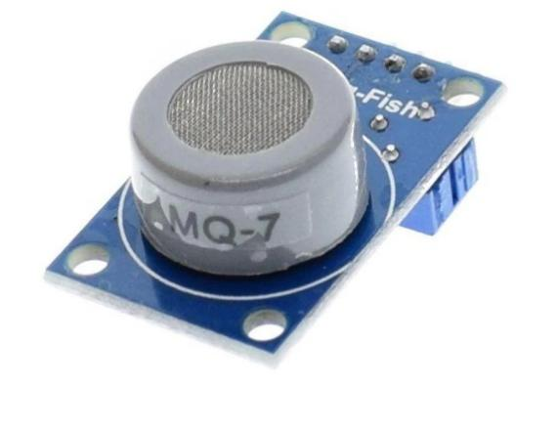

***Fig 1.5: MQ7 Sensor***

**1.4.6 ELECTROCHEMICAL OXYGEN SENSOR**

An electrochemical oxygen sensor is a type of gas sensor that measures the concentration of oxygen in a gas mixture using an electrochemical reaction. The sensor typically consists of a thin membrane made of a solid electrolyte material, with two electrodes placed on either side of the membrane.

When oxygen molecules encounter the membrane, they can pass through it and react with the electrode on the other side. This reaction produces an electrical signal that is proportional to the concentration of oxygen in the gas mixture. The sensor is typically housed in a protective casing and connected to an electronic circuit that interprets the electrical signal and provides a reading of the oxygen concentration.

Electrochemical oxygen sensors are commonly used in a variety of applications, including industrial process control, medical devices, and environmental monitoring. They are highly accurate and reliable, with fast response times and long lifetimes. However, they do require periodic calibration and maintenance to ensure accuracy and prevent drift over time.

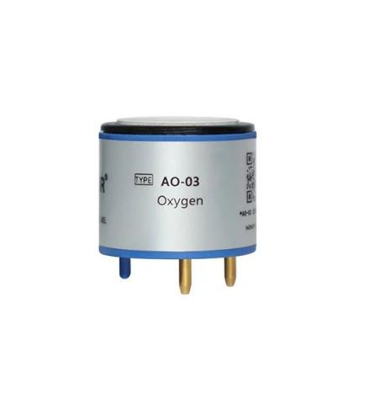

***Fig 1.6: Electrochemical Oxygen sensor***

**1.4.7 MG811-SENSOR**

The MG811 sensor is a type of carbon dioxide (CO2) gas sensor that is commonly used in applications such as indoor air quality monitoring, greenhouse gas monitoring, and ventilation control systems. It works on the principle of infrared absorption and is sensitive to the presence of CO2 in the air.

The MG811 sensor consists of an infrared light source, a CO2 sensing element, and an infrared detector. The CO2 sensing element absorbs the infrared radiation at a specific wavelength that is proportional to the concentration of CO2 in the air. The infrared detector then measures the amount of infrared radiation that is transmitted through the sensing element, which provides an indication of the CO2 concentration.

The output of the MG811 sensor is an analog voltage signal that varies in proportion to the CO2 concentration in the air. This signal can be read by a micro-controller or other electronics, which can then be used to control ventilation systems or provide feedback to users about the indoor air quality.

The MG811 sensor is known for its high sensitivity, low power consumption, and low cost, which makes it a popular choice for a variety of applications. However, it is important to calibrate the sensor periodically to ensure accurate readings over time.

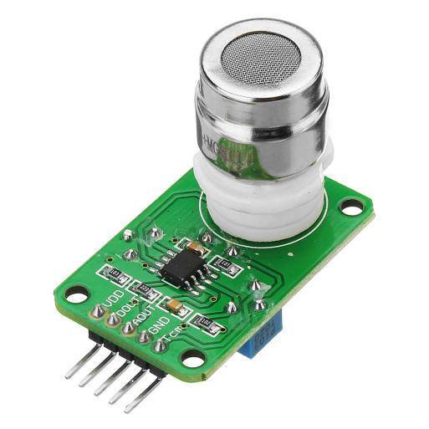

***Fig 1.7: MG811 Sensor***

**1.4.8 LCD DISPLAY**

An LCD (Liquid Crystal Display) display is a flat panel display that uses liquid crystals to display images. It is widely used in electronic devices such as televisions, computer monitors, and digital watches. LCD displays are popular because they are energy efficient, have a wide viewing angle, and can display high-resolution images. They are also lightweight and compact, making them ideal for portable devices.

LCD displays work by using a backlight to illuminate the liquid crystals, which are sandwiched between two layers of glass. When an electrical current is applied to the liquid crystals, they align to allow light to pass through and create an image. LCD displays can display images in black and white or color, and can be found in a range of sizes from small displays used in watches and calculators to large displays used in televisions and computer monitors. With their energy efficiency, high resolution, and wide range of sizes, LCD displays are a popular choice for a variety of applications.

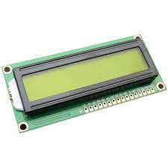

***Fig 1.8: LCD Display***

**1.5 RANGE OF THE SENSORS**

1. **PM10 Sensor:** Capable of detecting particle matter with a diameter between 2.5 and 10 µm
2. **MG811 Sensor:** Capable of sensing carbon dioxide air concentration levels between 350 and 10,000ppm.
3. **TGS3830 Sensor**: Capable of sensing halocarbon concentration levels between 5 and 100ppm.
4. **MQ7 Sensor:** Can measure concentrations of 10 to 10,000 ppm.

**1.6 SOFTWARE USED**

**1.6.1 ARDUINO IDE**

The Arduino IDE (Integrated Development Environment) is a user-friendly software platform designed for programming Arduino boards. It offers a simplified programming environment, making it accessible to beginners and advanced developers alike. With its code editor, you can write Arduino sketches, which are programs that run on Arduino microcontrollers. These sketches are structured into two main functions: setup() and loop(). The setup() function initializes variables and performs necessary setup tasks, while the loop() function runs repeatedly, providing continuous execution. The IDE's library manager simplifies the addition and management of libraries, which offer pre-written code modules for interacting with various hardware components. It also includes a compiler for translating code into machine-readable instructions, ensuring accuracy before uploading. The IDE's serial monitor tool allows communication with the Arduino board, aiding in debugging and testing. The Arduino IDE provides example sketches and online tutorials to support learning, and its active community shares projects, code examples, and troubleshooting tips. Overall, the Arduino IDE enables the development of interactive projects and prototypes with ease, contributing to its widespread popularity among makers and professionals.

**1.6.2 PROTEUS**

Proteus is a powerful simulation and design software used in the field of electronics. It provides a virtual platform for designing, testing, and simulating electronic circuits and systems. With its extensive range of features, Proteus enables engineers, students, and hobbyists to create and validate electronic designs before the physical implementation.

At its core, Proteus offers a comprehensive circuit simulation environment. Users can design circuits by selecting and connecting electronic components from its vast library, including microcontrollers, sensors, actuators, and other discrete components. The software allows for easy schematic capture and supports both analog and digital circuit design.

One of the key features of Proteus is its advanced simulation capabilities. Users can simulate their circuits to analyze and validate their functionality, performance, and behavior. The simulator takes into account real-world factors such as component characteristics, signal propagation, and timing effects. This enables engineers to detect potential issues, optimize designs, and ensure proper functioning before prototyping or manufacturing.

In addition to circuit simulation, Proteus provides a platform for designing and simulating micro controller-based systems. It supports popular micro controller families, such as Arduino, PIC, AVR, and ARM, allowing users to program and test their embedded systems virtually. This feature is particularly valuable for developing and debugging firmware or software without the need for physical hardware.

Proteus also offers the capability to design and simulate printed circuit boards (PCBs). Users can design PCB layouts, place components, define copper traces, and generate manufacturing files. The software ensures proper electrical connections, design rule checks, and even allows for 3D visualization of the PCB.

Furthermore, Proteus provides a co-simulation environment, enabling the integration of electronics and software simulation. Users can develop and test embedded software in conjunction with the electronic hardware, facilitating comprehensive system-level validation.

Overall, Proteus serves as a comprehensive tool for designing, simulating, and testing electronic circuits and systems. It helps reduce time-to-market, minimize development costs, and improve the reliability of electronic designs by offering a virtual environment for prototyping and validation.

**CHAPTER 2**

**LITERATURE REVIEW**

**2.1 REVIEW OF LITERATURE**

# 2.1.1 EFFECTS OF VEHICULAR EMISSIONS ON THE URBAN ENVIRONMENT

**Authors:** P. Gireesh Kumar, P. Lekhana, M.Tejaswi,S.Chandrakala , In journal of **Materials Today ,** [Volume 45, Part 7](https://www.sciencedirect.com/journal/materials-today-proceedings/vol/45/part/P7), 2021, Pages 6314-6320 <https://doi.org/10.1016/j.matpr.2020.10.739>

Environment plays a pivotal role in the human civilization; it is the key to the subsistence of life on Earth. The survival of the human being is perhaps impossible, without the proper environment and the major environmental issue that is causing massive concern is “the Pollution” which was being imparted by the road transports in particular. In most of the country’s urbanization have been increasing tardily, due to this urbanization the usage of private transport has raised to a great extent. Meteoric urbanization and heavy usage of vehicles have been the major sources of air pollution. In the present scenario, private transport has become the dominant form of transportation in almost all the countries. As every individual use their own vehicle for different purposes, the Vehicular emissions were largely increasing which may cause a great damage to the entire environment.

Air Pollution is the earth's enormous environmental issue and hence POLLUTION has been considered as a major challenge in this paper. Air Pollution refers to the contamination of air due to the gases, particulates and various pollutants, there are numerous sources of air pollution like burning of fossil fuels, pollution from factories and industries, deforestation, mining operations, emissions from the vehicles etc. Depending upon the type of engine utilized in a vehicle, the discharged gases contain different levels of chemical compounds. When compared to the Gasoline engines, diesel engines were immensely used because of their reliability, low working costs and high resilience. Diesel engine vehicles emit CO, HC, PM and NOx gases due to incomplete combustion and unburnt fuel. Vehicles with Internal Combustion Engines emit two types of pollutants.

They are Primary and Secondary, the primary pollutants are usually produced by different processes which include carbon monoxide from motor vehicles, Sulphur dioxide released from factories etc. whereas the secondary pollutants are not directly emitted into the atmosphere which include particulates created from gaseous primary pollutants. Comparing with all the industries, the Automobile industries one factor that contributes more to the world's economy and it has been the main source of urban environmental pollution in the developing countries like India. The tremendous raise in dominating the use of Motorized vehicles by the public for multi-purpose use (passenger/transport) witnessed in the developing countries because of its flexibility and versatility with low initial cost.

Fuel using vehicles doesn't utilize the fuel in the engine completely, the unwanted particulates in the fuel are released in the form of chemicals into the air which entirely disturbs the ecosystem. Vehicles such as bikes, cars, auto rickshaws, trucks etc. contribute to vehicular pollution but the emissions from the car plays a major role in polluting the air. The connection between the climate change, air pollution and the human health is that the pollutants in the air effects the quantity of incoming sunlight, with some pollutants warming and others cooling the earth and this distinction in the environment develops the allergies, respiratory disease and cardiovascular disease in the human body.

# 2.1.2 A REVIEW OF MAJOR CHLOROFLUOROCARBONS

## **Authors:** Ki-Hyun Kim , Zang-Ho Shon , Hang Thi Nguyen , Eui-Chan Jeon , In journal of [**Atmospheric Environment**](https://www.sciencedirect.com/journal/atmospheric-environment) [Volume 45, Issue 7](https://www.sciencedirect.com/journal/atmospheric-environment/vol/45/issue/7), March 2011, Pages 1369-1382

<https://doi.org/10.1016/j.atmosenv.2010.12.029>

Chlorofluorocarbons (CFC's) are a group of chemical compounds that contain chlorine, fluorine, and carbon atoms. They were widely used as refrigerants, solvents, and propellants in aerosol cans, among other things, because of their stability, non-toxicity, and low flammability. However, the widespread use of CFC's has had a significant negative impact on the environment and human health.

CFC's are known to be a major contributor to the depletion of the ozone layer, which protects the earth from harmful ultraviolet radiation. When CFC's are released into the atmosphere, they rise to the stratosphere and react with ozone molecules, breaking them down and reducing the amount of ozone in the atmosphere. This can lead to increased cases of skin cancer, cataracts, and other health problems in humans and animals.

Furthermore, CFC's are also potent greenhouse gases, contributing to global warming and climate change. In addition, they have been linked to other environmental issues such as acid rain and the depletion of natural resources.

In response to these concerns, the production and use of CFC's have been regulated by international agreements such as the Montreal Protocol, which was adopted in 1987. Under the Protocol, countries agreed to phase out the production and use of CFC’s and other ozone-depleting substances.

Overall, while CFC's were once seen as useful and harmless chemicals, their negative impact on the environment and human health has led to widespread efforts to phase them out and replace them with more sustainable alternatives.

**2.1.3 TROPOSPHERIC EMISSIONS: MONITORING OF POLLUTION (TEMPO)**

Selected in 2012 by **NASA ,** In journal of **Quantitative Spectroscopy and Radiative Transfer**,[Volume 186](https://www.sciencedirect.com/journal/journal-of-quantitative-spectroscopy-and-radiative-transfer/vol/186/suppl/C), January 2017, Pages 17-39 **,** <https://doi.org/10.1016/j.jqsrt.2016.05.008>

Tropospheric emissions: Monitoring of pollution (TEMPO) is a NASA-funded project that aims to provide more accurate measurements of air pollution in North America. The project is designed to measure pollution levels at high spatial and temporal resolution using a geostationary satellite.

TEMPO will provide data on a range of pollutants, including ozone, nitrogen dioxide, sulfur dioxide, formaldehyde, and aerosols. By monitoring these pollutants, TEMPO will help scientists and policymakers better understand the sources of air pollution and how it impacts human health and the environment.

One of the key features of TEMPO is its high spatial resolution. The geostationary satellite will be positioned over the United States, allowing for measurements of air pollution at a resolution of 2.1 square kilometers. This level of detail will enable researchers to identify pollution hotspots and sources, such as highways, power plants, and industrial facilities.

TEMPO will also provide data in near-real-time, making it possible to respond more quickly to air quality issues. This data will be available to the public through an online portal, enabling individuals and communities to make informed decisions about their activities and exposure to air pollution.

Overall, TEMPO has the potential to significantly improve our understanding of air pollution and its impacts on human health and the environment. By providing high-resolution, near-real-time data on a range of pollutants, this project will help to inform policies and actions that can reduce air pollution and improve public health.

**2.1.4 REVIEW ON VEHICLE EXHAUST EMISSION MONITORING SYSTEM**

**Authors:**[Karl Ropkins](https://www.tandfonline.com/author/Ropkins,+Karl), [Joe Beebe](https://www.tandfonline.com/author/Beebe,+Joe), [Hu Li](https://www.tandfonline.com/author/Li,+Hu), [Basil Daham](https://www.tandfonline.com/author/Daham,+Basil),[JamesTate](https://www.tandfonline.com/author/Tate,+James) ,[Margaret Bell](https://www.tandfonline.com/author/Bell,+Margaret) & [Gordon Andrews](https://www.tandfonline.com/author/Andrews,+Gordon), In journal of **Original Articles** , Pages 79- 152,<https://doi.org/10.1080/10643380701413377>

A Vehicle Exhaust Emission Monitoring System is a device that measures the amount of pollutants emitted by a vehicle's exhaust system. These systems are typically used to ensure compliance with emission standards set by regulatory agencies and to monitor the health and environmental impact of vehicle emissions.

One of the key benefits of a vehicle exhaust emission monitoring system is that it provides accurate and reliable data on the amount and type of pollutants emitted by vehicles. This data can help to identify sources of pollution and inform policies and actions that can reduce emissions and improve air quality.

In addition to monitoring emissions from individual vehicles, these systems can also be used to assess the overall impact of transportation on air quality. By collecting data on emissions from a range of vehicles over time, researchers can identify trends and patterns in emission levels and develop strategies to reduce pollution.

Another benefit of vehicle exhaust emission monitoring systems is that they can provide feedback to drivers on their driving behavior and the impact of their vehicle on the environment. This feedback can help to raise awareness about the importance of reducing emissions and encourage more environmentally responsible driving practices. However, there are also some limitations and challenges associated with vehicle exhaust emission monitoring systems. For example, these systems can be expensive to install and maintain, and they may not be able to accurately measure emissions under all driving conditions.

Additionally, there can be variability in emissions between different vehicles of the same model, which can make it difficult to compare emission levels.

Overall, a vehicle exhaust emission monitoring system can be an effective tool for measuring and reducing vehicle emissions. While there are some challenges associated with these systems, their benefits in terms of improving air quality and reducing the impact of transportation on the environment make them an important technology for the future.

**2.1.5 IOT BASED VEHICLE EMISSION MONITORING SYSTEM**

**Authors:** P. Arun Mozhi Devan; Fawnizu Azmadi Hussin; Rosdiazli Ibrahim; Kishore Bingi; M. Nagarajapandian,In journal of **IEE Conference**, (Vol.11, No. 1,p19137003)DOI: 10.1109/SCORED.2019.8896289

An IoT-based Vehicle Emission Monitoring System is a technology that enables the monitoring of vehicle emissions in real-time using the Internet of Things (IoT) devices. These systems are designed to collect and analyze data from sensors attached to a vehicle's exhaust system, providing information on the amount and type of pollutants emitted by the vehicle.

One of the key benefits of an IoT-based vehicle emission monitoring system is that it provides real-time data on emissions, enabling immediate action to be taken to reduce pollution. For example, if a vehicle is found to be emitting high levels of pollutants, the system can alert the driver or fleet manager, who can take steps to address the issue and reduce emissions.

Another benefit of IoT-based vehicle emission monitoring systems is that they can provide valuable data for research and policy development. By collecting data on emissions from a large number of vehicles over time, researchers and policymakers can identify trends and patterns in emission levels and develop strategies to reduce pollution.

Furthermore, these systems can also provide valuable insights into driver behavior and vehicle performance. By analyzing data on driving patterns and vehicle emissions, IoT-based systems can help to identify areas where improvements can be made to reduce emissions and improve fuel efficiency.

However, there are also some challenges associated with IoT-based vehicle emission monitoring systems. For example, these systems can be expensive to install and maintain, and there may be issues with data accuracy and reliability. Additionally, there may be concerns about data privacy and security, as these systems collect sensitive information about individual vehicles and drivers.

Overall, an IoT-based vehicle emission monitoring system can be an effective tool for reducing vehicle emissions and improving air quality. While there are some challenges associated with these systems, their benefits in terms of real-time monitoring, research, and policy development make them a promising technology for the future.

**CHAPTER 3**

**METHODOLOGY**

**3.1 PROPOSED MODEL**

The proposed model for an emission monitoring system aims to provide an efficient and accurate way of measuring and monitoring air pollution levels with real time visual representation. The system includes sensors that detect different types of pollutants, a microcontroller that processes the sensor data, an lcd display that provides a real time visual representation and is IoT enable which helps transmit data wirelessly to a cloud based platform for analysis and visualization.

The multi-sensor integration aims to achieve integrating various sensors to detect different types of emission in the environment, providing a more comprehensive visualization of the air quality. The sensors are calibrated to the desired levels of exposure to the emissions by the factors provided in the code for the microcontroller to match the sensor response.

The IoT-enabled sensors can detect different types of pollutants, such as carbon monoxide, oxygen, chlorofluorocarbons and particulate matter, and convert the amount of pollutants present in the air into an electrical signal. The microcontroller processes the data from the sensors and sends it wirelessly to a cloud-based platform for storage and analysis.

One of the key benefits of the proposed model is that it enables real-time monitoring of air pollution levels. The cloud-based platform can analyze the data in real-time and provide a visual representation of the air quality levels. This enables users to easily interpret and understand the air quality levels and take immediate action if necessary.

The cloud-based platform can be accessed from anywhere, allowing users to monitor air quality levels in different locations simultaneously. This makes the system highly scalable and adaptable to different use cases. The user end dashboard that is used to analyze the emission levels is extremely user friendly and can be used by any individual for various monitoring and analytical purposes

**3.2 FLOWCHART OF THE WORKING MODEL**

Concentrations received?

Get inputs from multiple sensors

Are the levels normal?

Continue displaying data

Display data and alert

Store the data

No

Yes

Yes

No

Power

***Fig 3.1: Flowchart of the proposed solution***

**3.2.1 EXPLANATION OF THE FLOWCHART**

1. **Sensor Data Acquisition:** The sensors used in the system detect the levels of pollutants in the air and convert the amount of pollutant present into an electrical signal that can be read by the microcontroller.
2. **Signal Processing:** The Arduino board processes the sensor data by amplifying, filtering, and digitizing the analog signal. The processed data is stored in the microcontroller's memory or transmitted wirelessly to a computer or mobile device for further analysis.
3. **Calibration:** The system needs to be calibrated periodically to ensure accurate measurement of pollutants. Calibration involves exposing the sensors to a known concentration of pollutants and adjusting the calibration factors in the code to match the sensor response.
4. **Data Visualization:** The results are displayed on a display interface, such as an LCD screen or a mobile app. The display can show the concentration of pollutants in real-time, as well as historical data for analysis.

**3.3 DATA FLOW OF THE PROPOSED SOLUTION**

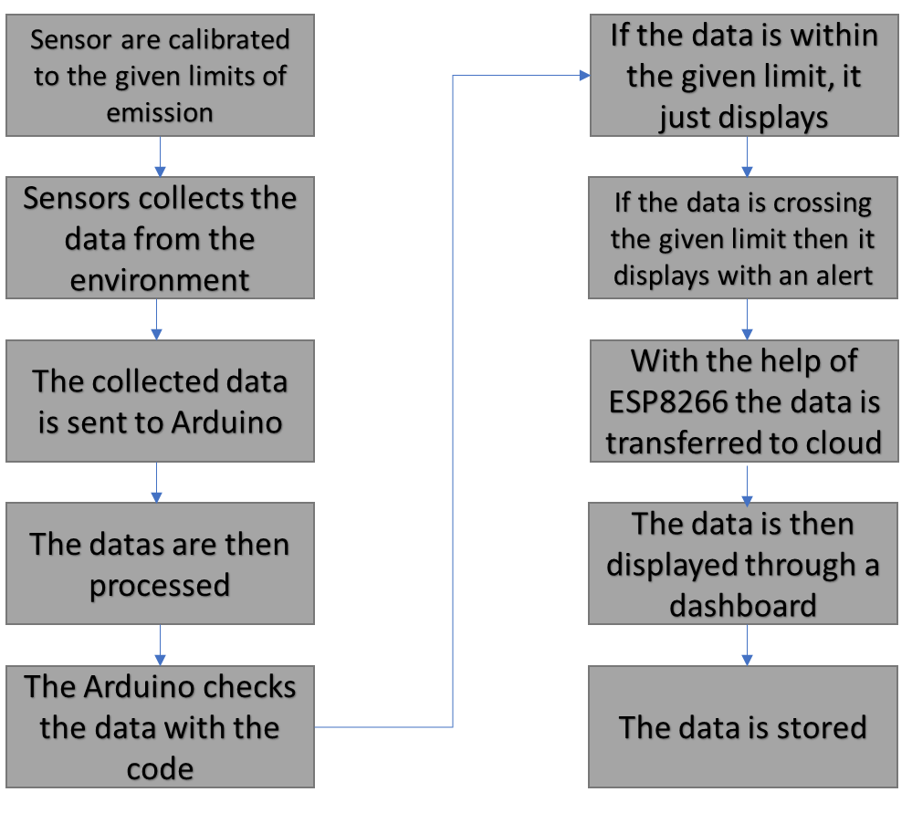

***Fig 3.2: Data flow of the proposed solution***

**3.4 BLOCK DIAGRAM OF THE PROPOSED SOLUTION**

***Fig 3.3: Block Diagram of the proposed solution***

**3.4.1 WORKING OF THE BLOCK DIAGRAM**

The working of the proposed project is that it utilizes a microcontroller, which is a small computer on a single integrated circuit, used to control various sensors and reads the input from these sensors. Different sensors collect different emission level from the environment and sends it as an input to the microcontroller.

In this system, the emissions rates of chlorofluorocarbon, particulate matters, oxygen and carbon monoxide are measured. This system also projects the levels of emission of gases and particle matters in the environment through an output display connected to the microcontroller. The microcontroller is set to send output signals to the display used.

The project is incorporated with IoT technology which enables the user to receive the data collected by the sensors by the means of a software enables cloud communication. With the help of this IoT technology, a person can even view the data with the help of a remote device that has the dashboard of the respective module. The various data collected that is displayed on the screen can be used to analyze and further to control these emission levels with a filter.

***Fig 3.4: Front view of the proposed solution***

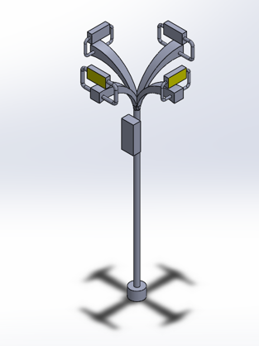

***Fig 3.5: Isometric view of the proposed solution***

**CHAPTER 4**

**RESULT AND DISCUSSION**

**4.1 RESULT**

A vehicle emission monitoring system is a vital tool for ensuring that vehicles are not emitting harmful pollutants that contribute to air pollution and negative health effects. The system works by analyzing the gases emitted by the vehicle and providing information about the level of pollutants being emitted. This information can be used to identify vehicles that are not meeting emission standards and take appropriate action to reduce the harmful impact on the environment and public health. The results of the monitoring system can also help one to design a required filtering system that can be used to reduce the emission. Overall, a vehicle emission monitoring system is an essential tool for promoting environmental sustainability and public health by reducing harmful vehicle emissions and ensuring that vehicles are operating within legal and regulatory requirements.

***Fig 4.1: Circuit diagram of the proposed solution***

**CHAPTER 5**

**CONCLUSION**

**5.1 CONCLUSION**

In conclusion, implementing an emission monitoring system (EMS) on a college campus can have significant benefits for both the environment and the campus community. By measuring and monitoring emissions from buildings, transportation, and other sources, an EMS can help identify areas where emissions can be reduced, leading to improved air quality, reduced greenhouse gas emissions, and increased sustainability.

Moreover, an EMS can help colleges and universities comply with environmental regulations and demonstrate their commitment to sustainability and environmental stewardship. This can be particularly important for attracting students and faculty who are increasingly focused on environmental issues and sustainability.

Implementing an EMS on a college campus can also provide educational opportunities for students and faculty. By involving students in the development and implementation of an EMS, they can gain hands-on experience in environmental monitoring, data analysis, and sustainability practices. Moreover, an EMS can be used as a teaching tool, providing opportunities for research, coursework, and outreach activities related to environmental and sustainability issues.

However, implementing an EMS on a college campus can also face challenges and constraints, such as limited financial resources, complex regulatory requirements, and resistance to change. To overcome these challenges, it is important for colleges and universities to prioritize sustainability and environmental stewardship, allocate resources for EMS development and implementation, and involve all stakeholders, including students, faculty, staff, and community members, in the process.

In conclusion, implementing an EMS on a college campus can provide significant environmental, educational, and social benefits. By taking a proactive approach to sustainability and environmental stewardship, colleges and universities can contribute to a more sustainable future and inspire the next generation of environmental leaders.

**5.2 FUTURE WORK**

The future scope of the vehicle emission monitoring system can be developed in many ways. One such way is that it helps creating a database management system that can be used to keep track of emission levels through a particular time.

This project can also be further developed such that by using the data of various emissions, we can design a suitable filter unit that can help reducing and maintaining the emission levels. This filter will provide a safer and cleaner environment for the people and the ecosystem.

**CHAPTER 6**

**REFERENCES**

1. Zhang, Z., Wang, H., Wu, Y., & He, K. (2017). China's vehicle emission control policies and their impacts on air pollution and public health. Journal of Environmental Sciences, Vol:51, Pg no:150-161. doi: 10.1016/j.jes.2016.05.048
2. Vaishnavi Kulkarni, Priyanka Mudaliar, Rutuja Jaid. IOT Based Application for Monitoring and Predicting Air Quality in the environment. Asian Journal of Convergence in Technology. Volume VII and Issue II ISSN NO: 2350-1146 I.F-5.11
3. Anand, S., Sharma, S. K., & Sharma, A. (2019). Air pollution from vehicular emissions: a review. Journal of Environmental Engineering and Landscape Management, 27(2), 80-94.IEA. (2020). Global Energy Review 2020. International Energy Agency.
4. Xu, Y., Ma, S., Yang, X., & Chen, H. (2020). Vehicle emission control technologies: a review. Journal of Cleaner Production, 261(2020), 121114. Doi: 10.1
5. Juniastel Rajagukguk, Rani Atika Pratiwi and E Kaewnuam. Emission Gas Detector (EGD) for Detecting Vehicle Exhaust Based on Combined Gas Sensors. The 8th International Conference on Theoretical and Applied Physics, Journal of Physics: Conf. Series 1120 (2018) 012020 IOP Publishing doi:10.1088/1742-6596/1120/1/012020.
6. Arun Mozhi Devan, Universiti Teknologi PETRONAS, Seri Iskandar, Perak, Malaysia Fawnizu Azmadi Hussin: Rosdiazli Ibrahim: Kishore Bingi: M. Nagarajapandian. IoT Based Vehicle Emission Monitoring and Alerting System. 2019 IEEE Student Conference on Research and Development (SCOReD), 978-1-7281-2613-5/19 ©2019 IEEE.
7. Dennis A. Martillano, Joshua Miguel R. Dita. Christian G. Cruz, and Kunal S. Sadhra, Android Based Real-Time Industrial Emission Monitoring System Using IoT Technology. Journal of Communications (Vol. 12, No. 11, November 2017), doi:10.12720/jcm.12.11.623-629, **DOI:**10.1109/SCORED.2019.8896289
8. Cordova-Lopez, L.E., Mason, A., Cullen, J.D., Shaw, A. and Al-Shamma’a, A.I., 2007. Online vehicle and atmospheric pollution monitoring using GIS and wireless sensor networks. In Journal of Physics:Conference Series (Vol. 76, No. 1, p. 012019). IOP Publishing.
9. Drew R. Gentner Orcid, Shantanu H. Jathar Orcid, Timothy D. Gordon, Roya Bahreini, Douglas A. Day, Imad El Haddad, Patrick L. Hayes,Diesel Motor Vehicle Emissions.In Journal of Environ.Sci.Technol.(Vol:51,Pg no:1074-1093) <https://doi.org/10.1021/acs.est.6b04509>

# [P. Arun Mozhi Devan](https://ieeexplore.ieee.org/author/37087088838); [Fawnizu Azmadi Hussin](https://ieeexplore.ieee.org/author/37293874900); [Rosdiazli Ibrahim](https://ieeexplore.ieee.org/author/37682409200); [Kishore Bingi](https://ieeexplore.ieee.org/author/37086001378); [M. Nagarajapandian](https://ieeexplore.ieee.org/author/37086870090). IoT Based Vehicle Emission Monitoring and Alerting System.In journal of IEE Conference,(Vol.11, No.1,p19137003)DOI: 10.1109/SCORED.2019.8896289

# 

**APPENDIX**

**Source code 1:**

#include <LiquidCrystal.h>

LiquidCrystal lcd(12, 11, 5, 4, 3, 2);

int buzzerPin = 9;

int mq7Pin = A0;

void setup()

{

pinMode(buzzerPin, OUTPUT);

lcd.begin(16, 2);

lcd.print("Gas Sensor Test");

delay(2000);

}

void loop()

{

int mq7Value = analogRead(mq7Pin);

if (mq7Value > 600)

{

lcd.clear();

lcd.print("Gas Detected!");

digitalWrite(buzzerPin, HIGH);

delay(1000);

digitalWrite(buzzerPin, LOW);

delay(1000);

} else

{

lcd.clear();

lcd.print("No Gas Detected");

digitalWrite(buzzerPin, LOW);

delay(1000);   }}

**Source Code 2:**

#define BLYNK_TEMPLATE_ID "TMPL36n6Uwfij"

#define BLYNK_TEMPLATE_NAME "emission monitoring"

#define BLYNK_AUTH_TOKEN "kt9jntsrPLu6zSwrk56JfcNyOtl7uRDH"

#define BLYNK_PRINT Serial

#include <ESP8266WiFi.h>

#include <BlynkSimpleEsp8266.h>

char auth[] = "kt9jntsrPLu6zSwrk56JfcNyOtl7uRDH";

char ssid[] = "dlink-D604";

char pass[] = "Mynet@b42";

int mq7_pin = A0;

void setup()

{

Serial.begin(9600);

Blynk.begin(auth, ssid, pass);

}

void loop()

{

float mq7_value = analogRead(mq7_pin);

float ppm = mq7_value * (5.0 / 1023.0) * 1000.0 / 10.0;

Serial.print("MQ7 value: ");

Serial.print(mq7_value);

Serial.print(" PPM: ");

Serial.println(ppm);

Blynk.virtualWrite(V0, ppm);

delay(1000)

  Blynk.run();